Angle Bisector

Definition
# Source: AI Source: Provided by: [Data Path: Persons Table -> ID Column: 1, Name_En Column: Motasem Essam] -> From: [ChatGPT] on [7/25/2026]
An angle bisector is a line, ray, or segment that divides an angle into two congruent angles.
If ray $\vec{BD}$bisects $∠ABC$, then:
$$\boxed{∠ABD=∠DBC}$$
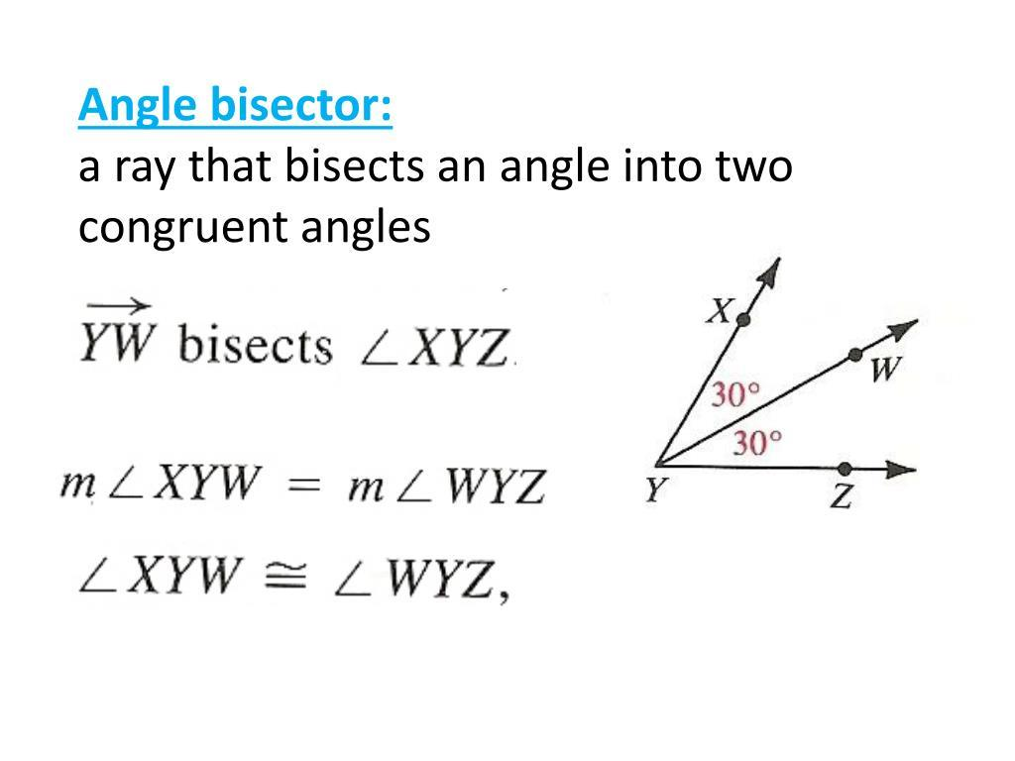
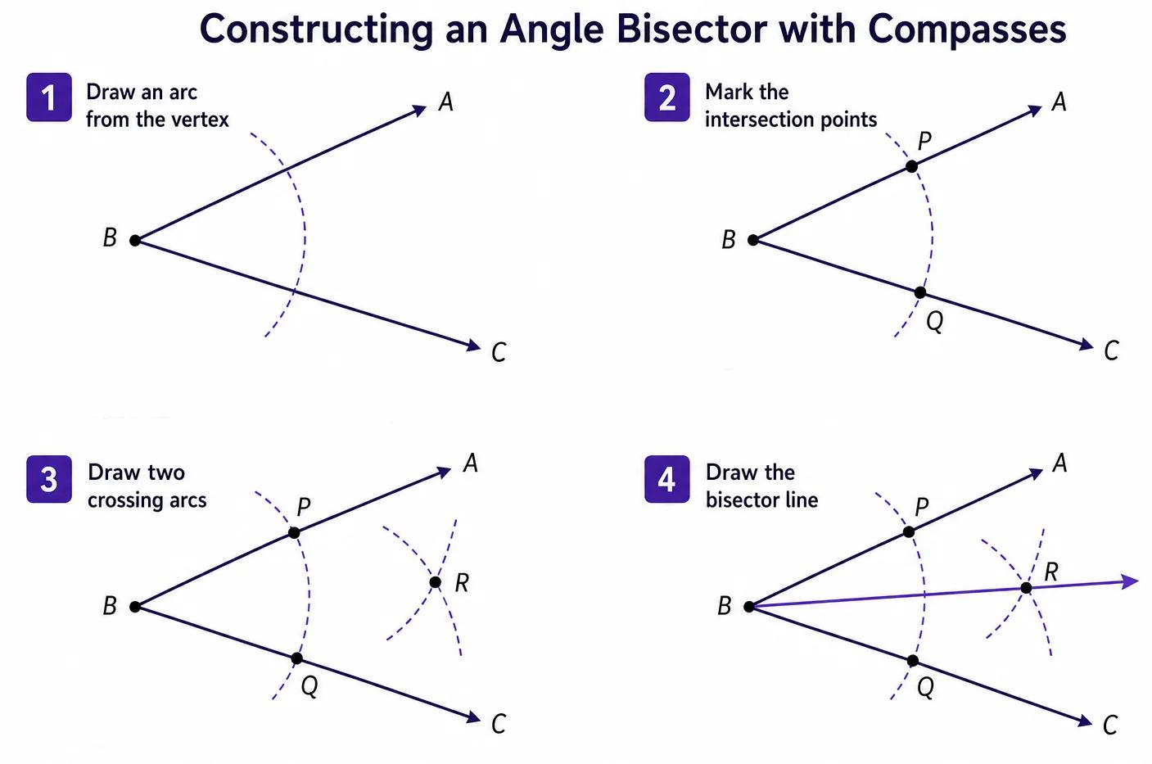
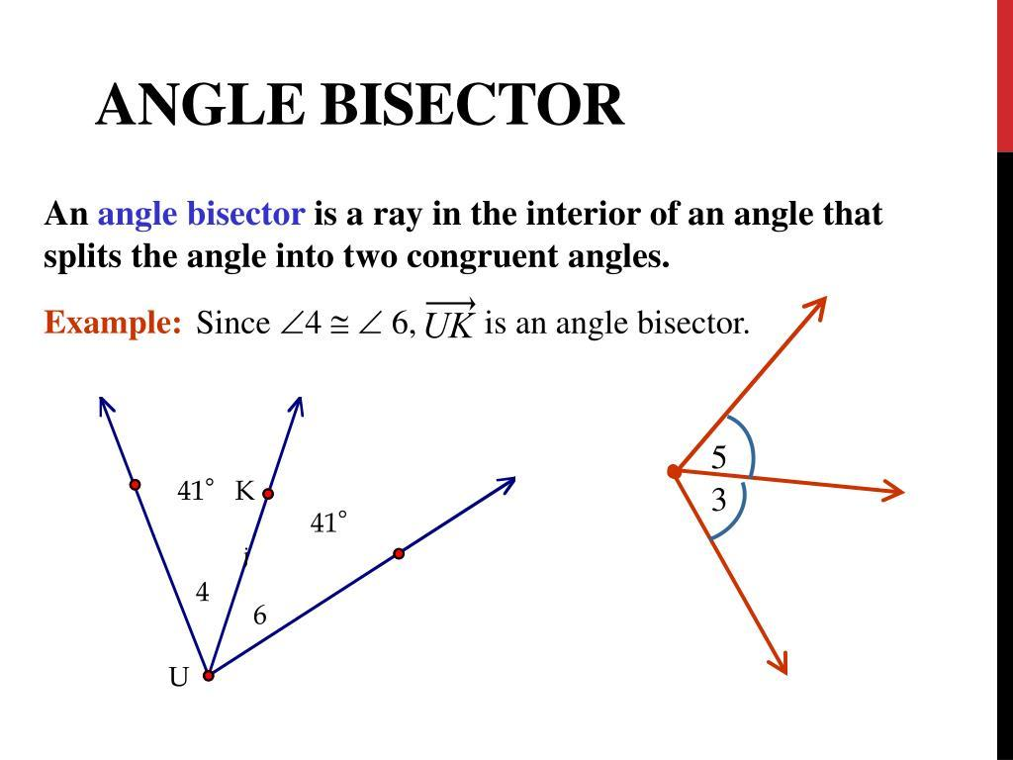
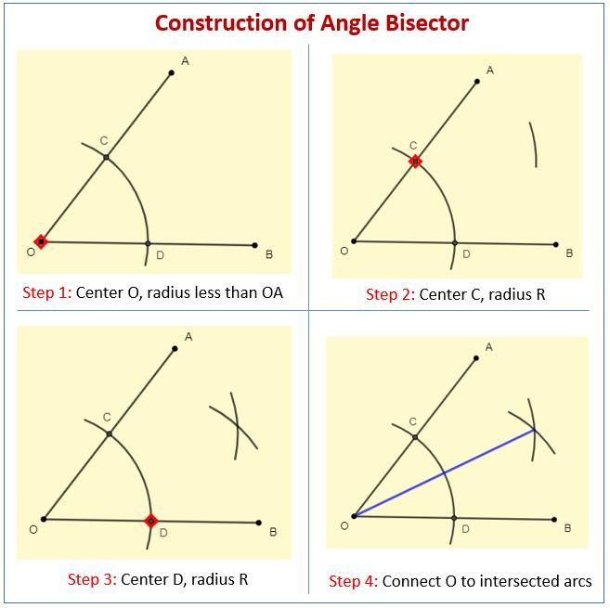
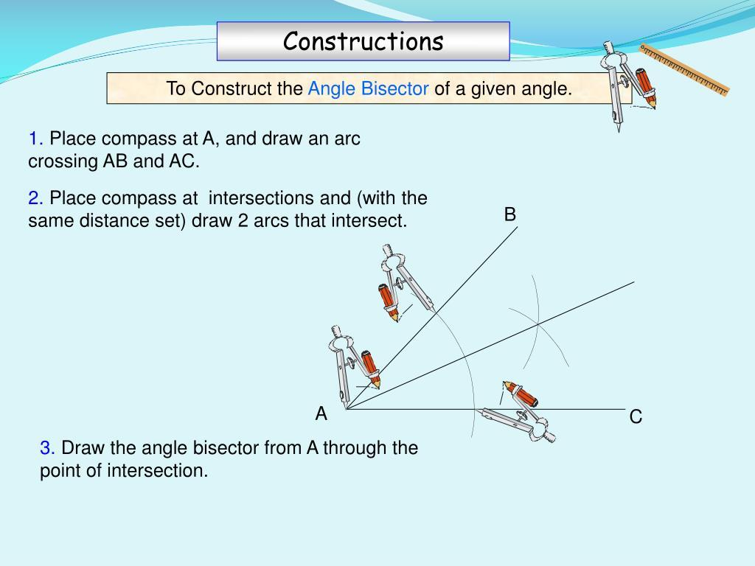
The point or ray that performs the division is called the angle bisector.

Purpose
# Source: AI Source: Provided by: [Data Path: Persons Table -> ID Column: 1, Name_En Column: Motasem Essam] -> From: [ChatGPT] on [7/25/2026]
An angle bisector is used to:
- Divide an angle into two equal angles.
- Construct specific angles.
- Find the center of an angle.
- Solve geometric problems involving equal angles.
- Locate the incenter of a triangle.
- Apply the Angle Bisector Theorem.

Basic Configuration
# Source: AI Source: Provided by: [Data Path: Persons Table -> ID Column: 1, Name_En Column: Motasem Essam] -> From: [ChatGPT] on [7/25/2026]
Consider $∠ABC$.
If ray $\vec{BD}$divides the angle into two equal parts:
$$∠ABD=∠DBC$$
then $\vec{BD}$is the angle bisector.
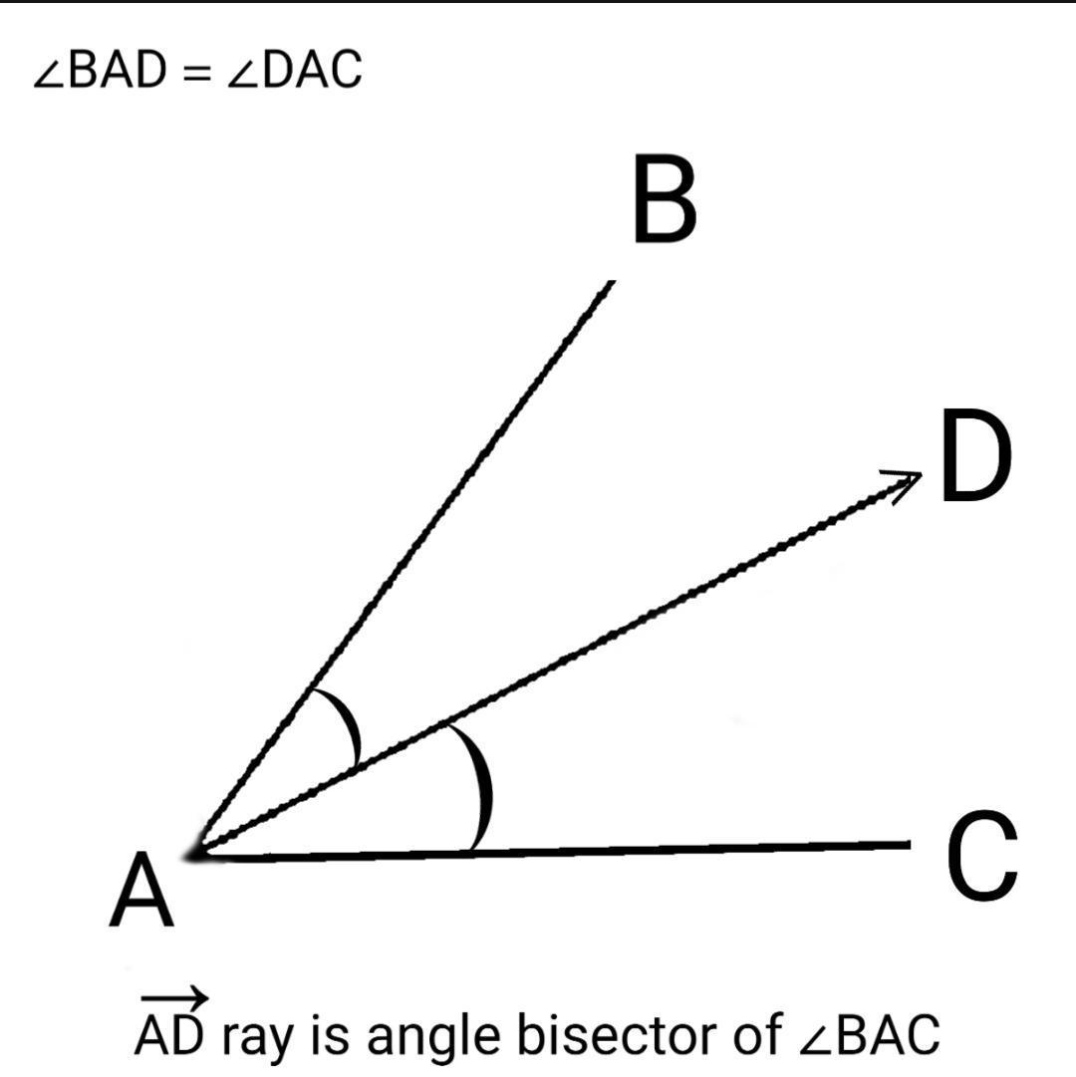
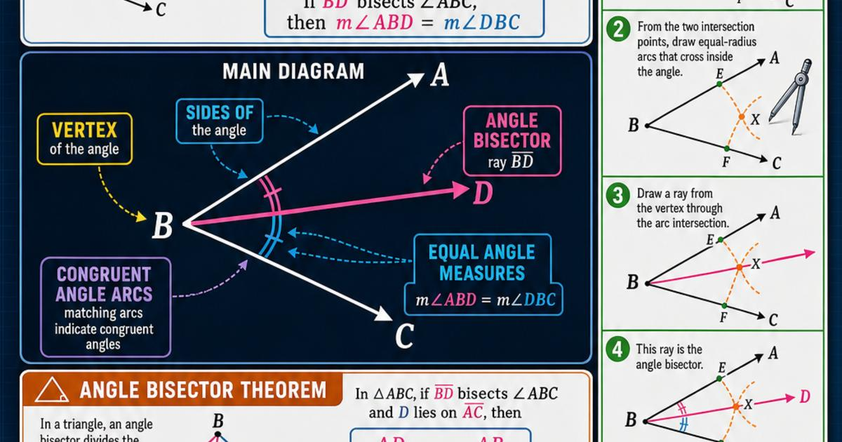
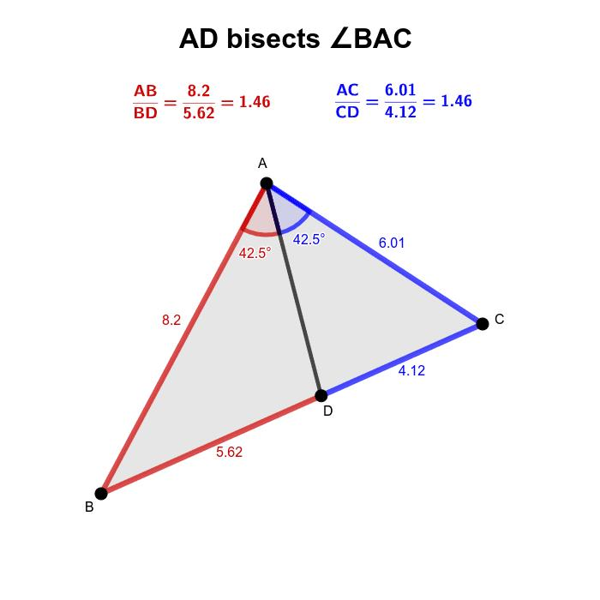
The configuration is:
$$\boxed{∠ABC=∠ABD+∠DBC}$$
Since the two angles are equal:
$$\boxed{∠ABD=∠DBC=\frac{∠ABC}{2}}$$

Fundamental Property
# Source: AI Source: Provided by: [Data Path: Persons Table -> ID Column: 1, Name_En Column: Motasem Essam] -> From: [ChatGPT] on [7/25/2026]
If $BD$bisects $∠ABC$, then:
$$\boxed{∠ABD=∠DBC}$$
Therefore, if:
$$∠ABC=θ$$
then:
$$\boxed{∠ABD=∠DBC=\frac{θ}{2}}$$

Example 1: Finding the Two Angles
# Source: AI Source: Provided by: [Data Path: Persons Table -> ID Column: 1, Name_En Column: Motasem Essam] -> From: [ChatGPT] on [7/25/2026]
Suppose:
$$∠ABC={80}^{∘}$$
and $BD$is the angle bisector.
Therefore:
$$∠ABD=∠DBC$$
Each angle is:
$$\frac{{80}^{∘}}{2}={40}^{∘}$$
Thus:
$$\boxed{∠ABD={40}^{∘}}$$
and:
$$\boxed{∠DBC={40}^{∘}}$$

Example 2: Finding the Original Angle
# Source: AI Source: Provided by: [Data Path: Persons Table -> ID Column: 1, Name_En Column: Motasem Essam] -> From: [ChatGPT] on [7/25/2026]
Suppose:
$$∠ABD={35}^{∘}$$
and $BD$is the angle bisector.
Because the two parts are equal:
$$∠DBC={35}^{∘}$$
Therefore:
$$∠ABC={35}^{∘}+{35}^{∘} \\ \boxed{∠ABC={70}^{∘}}$$

Angle Bisector in a Triangle
# Source: AI Source: Provided by: [Data Path: Persons Table -> ID Column: 1, Name_En Column: Motasem Essam] -> From: [ChatGPT] on [7/25/2026]
An angle bisector can be drawn from a vertex of a triangle to the opposite side.
For triangle $△ABC$, if $AD$bisects $∠A$:
$$\boxed{∠BAD=∠DAC}$$
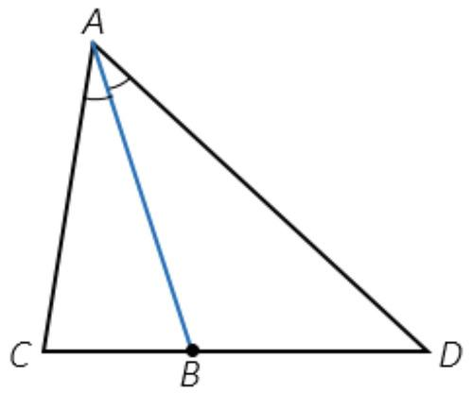
The point $D$lies on side $\overset{‾}{BC}$.

Angle Bisector Theorem
# Source: AI Source: Provided by: [Data Path: Persons Table -> ID Column: 1, Name_En Column: Motasem Essam] -> From: [ChatGPT] on [7/25/2026]
The angle bisector of a triangle has an important relationship with the opposite side.
If $AD$bisects $∠A$in $△ABC$, then:
$$\boxed{\frac{BD}{DC}=\frac{AB}{AC}}$$
This means that the angle bisector divides the opposite side proportionally to the two adjacent sides.
Example
If:
$$AB=6$$
and:
$$AC=9$$
then:
$$\frac{BD}{DC}=\frac{6}{9}$$
so:
$$\boxed{BD:DC=2:3}$$
The two segments $BD$and $DC$are therefore not necessarily equal.

Internal Angle Bisector
# Source: AI Source: Provided by: [Data Path: Persons Table -> ID Column: 1, Name_En Column: Motasem Essam] -> From: [ChatGPT] on [7/25/2026]
An internal angle bisector lies inside the angle and divides the interior angle into two equal angles.
For example:
$$∠ABC={60}^{∘}$$
The internal angle bisector produces:
$${30}^{∘}+{30}^{∘}$$
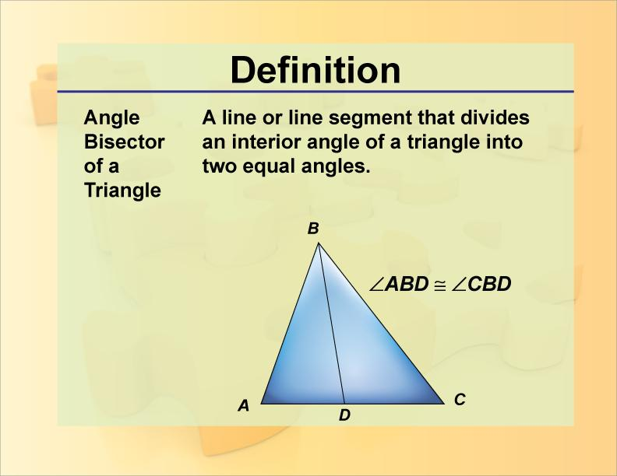
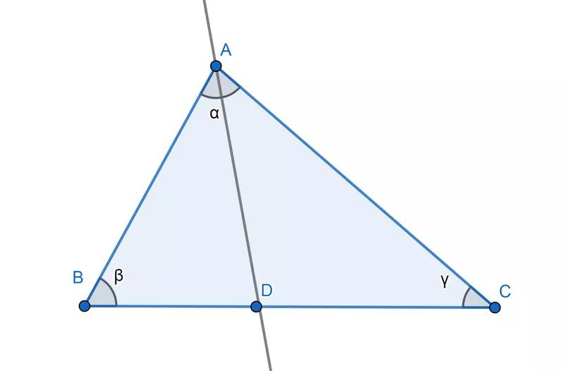
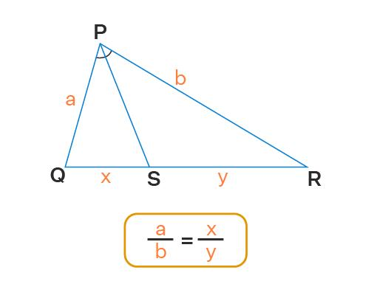

External Angle Bisector
# Source: AI Source: Provided by: [Data Path: Persons Table -> ID Column: 1, Name_En Column: Motasem Essam] -> From: [ChatGPT] on [7/25/2026]
An external angle bisector bisects the angle formed by the extensions of the two sides of an angle.
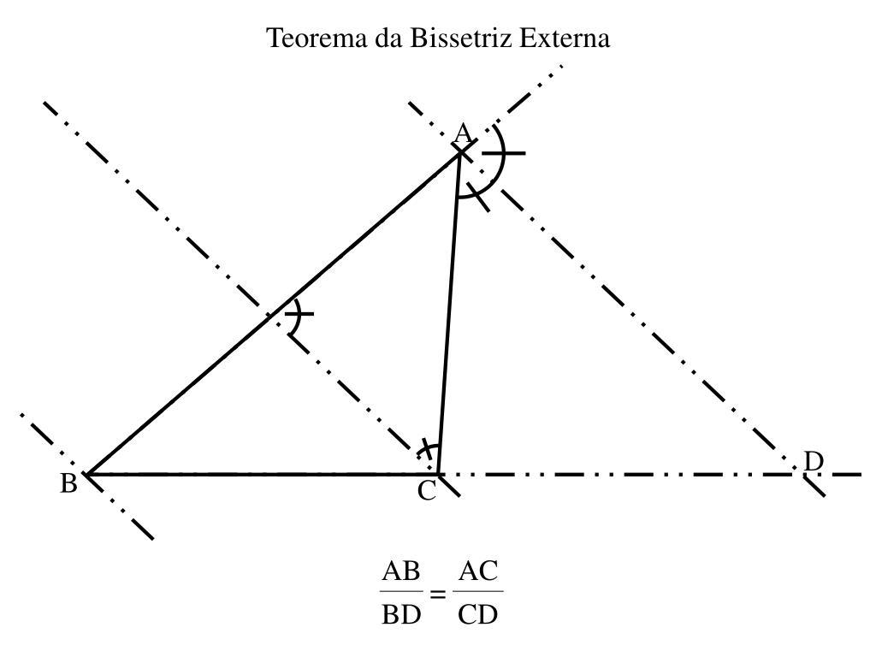
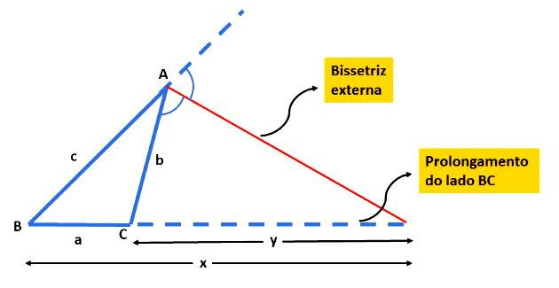
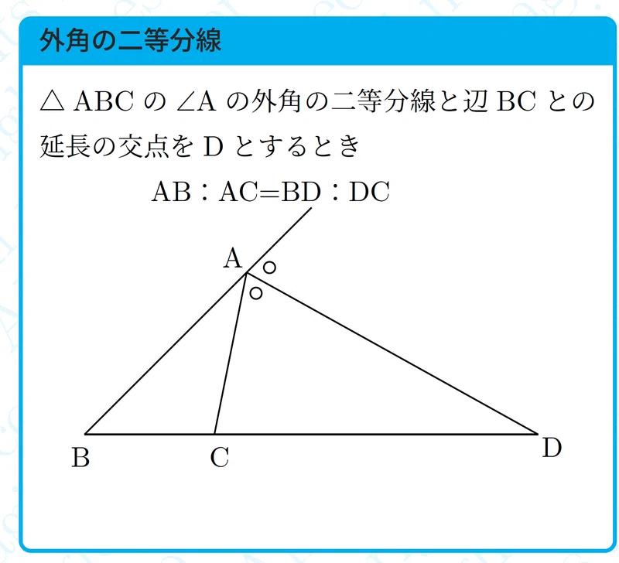
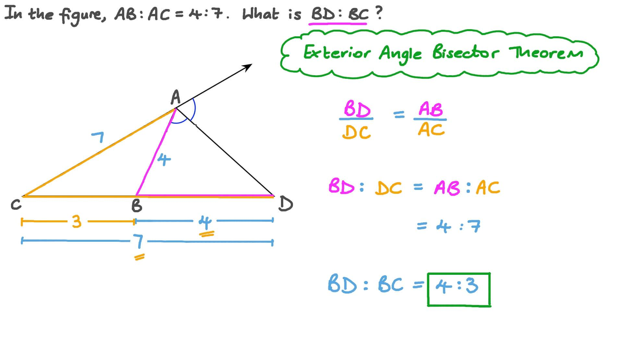
For a triangle, the external angle bisectors are related to the excenters.
An important distinction is:
- Internal angle bisector → passes through the interior of the angle.
- External angle bisector → bisects the corresponding exterior angle.

Angle Bisectors of a Triangle
# Source: AI Source: Provided by: [Data Path: Persons Table -> ID Column: 1, Name_En Column: Motasem Essam] -> From: [ChatGPT] on [7/25/2026]
Every triangle has three internal angle bisectors, one from each vertex.
They intersect at one point called the incenter.
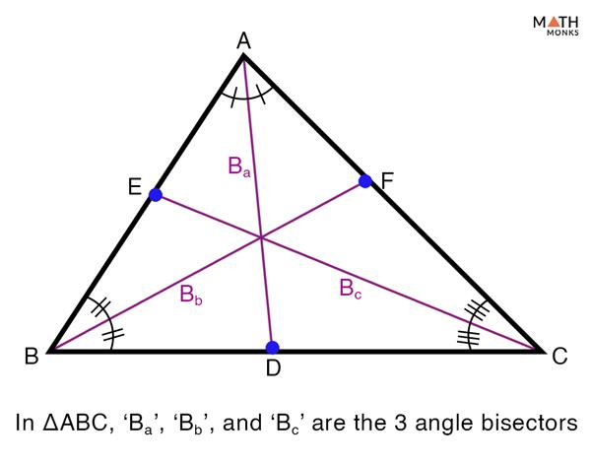
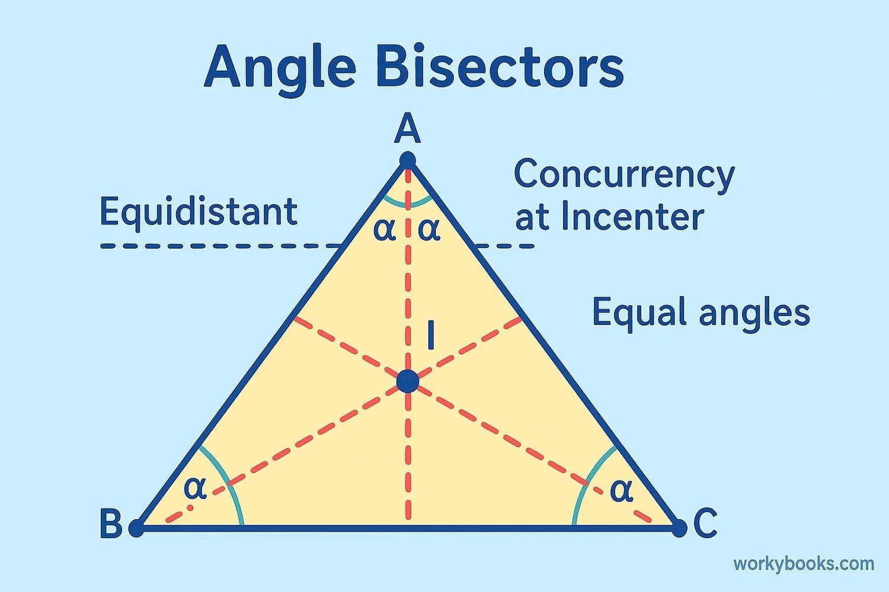
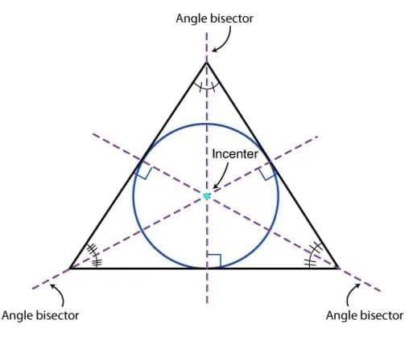
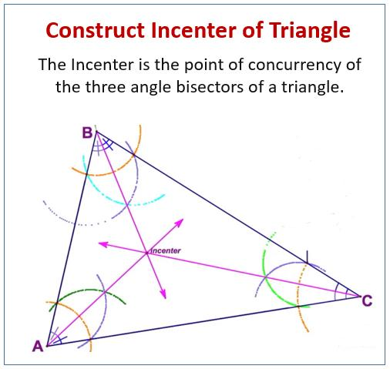
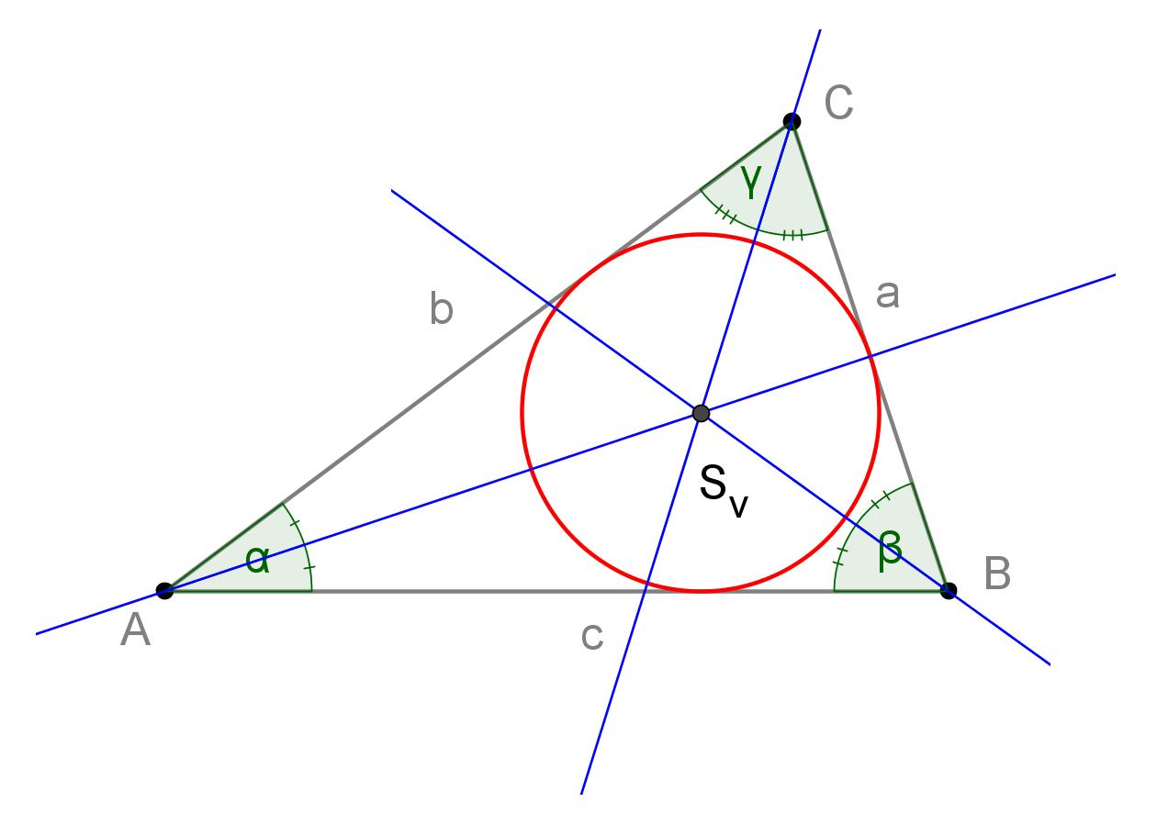
The incenter is therefore:
$$\boxed{\text{Intersection of the three internal angle bisectors}}$$
The incenter is equidistant from the three sides of the triangle.

Constructing an Angle Bisector
# Source: AI Source: Provided by: [Data Path: Persons Table -> ID Column: 1, Name_En Column: Motasem Essam] -> From: [ChatGPT] on [7/25/2026]
An angle bisector can be constructed using a compass and straightedge.
Steps
- Place the compass at the vertex of the angle.
- Draw an arc intersecting both sides of the angle.
- Place the compass at each intersection point.
- Draw two arcs that intersect inside the angle.
- Draw a ray from the original vertex through the intersection of those arcs.
The resulting ray is the angle bisector.
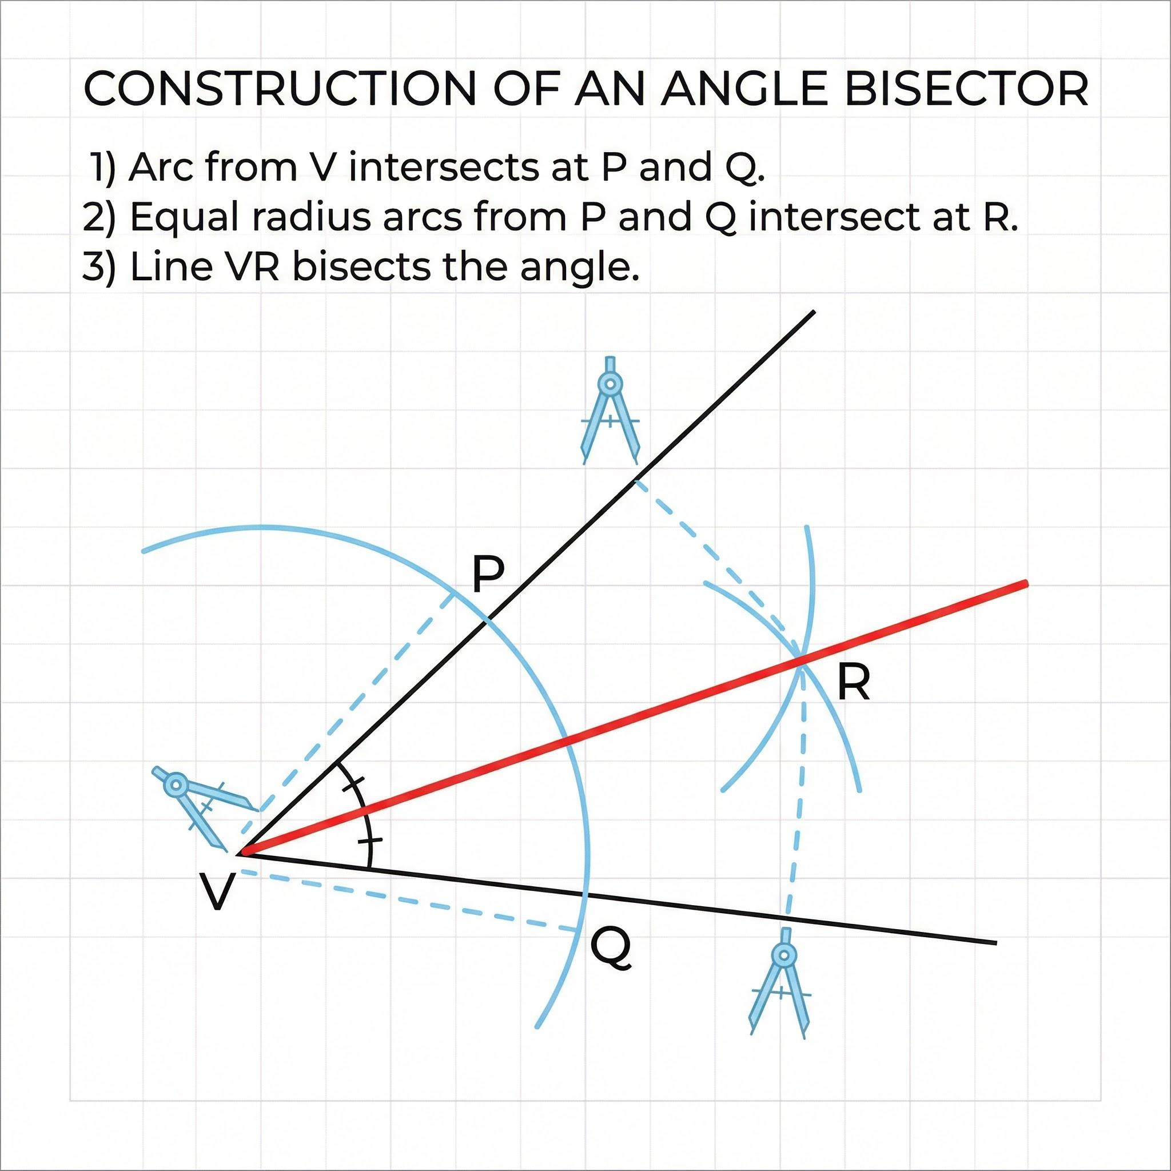
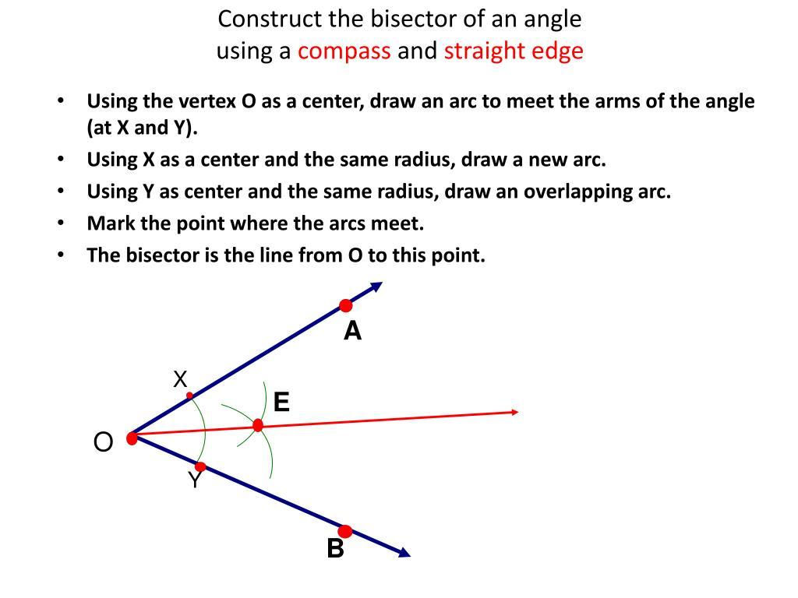
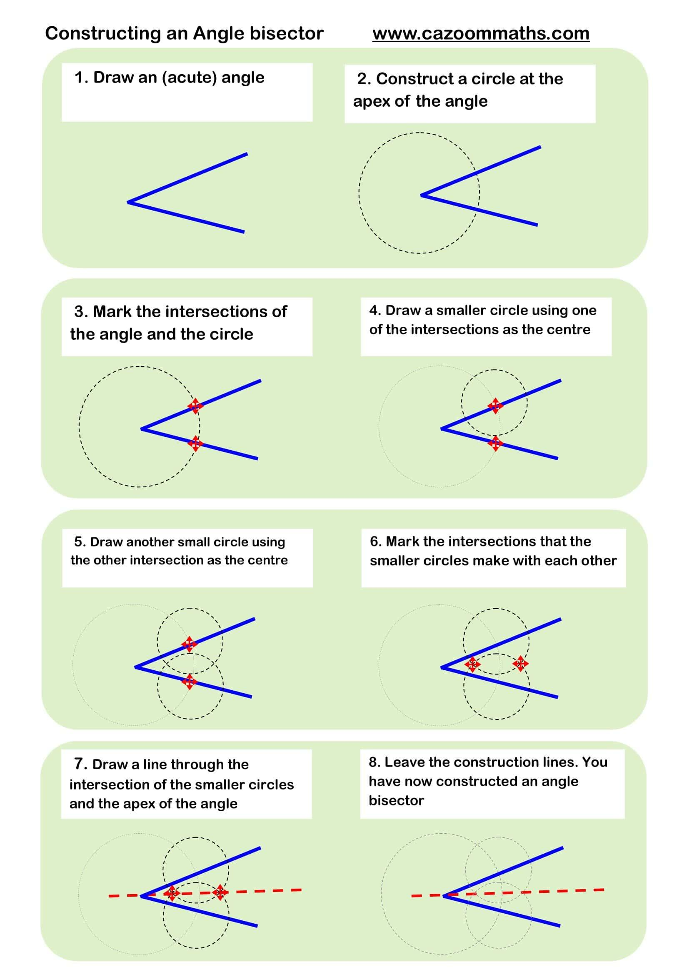

Important Properties
# Source: AI Source: Provided by: [Data Path: Persons Table -> ID Column: 1, Name_En Column: Motasem Essam] -> From: [ChatGPT] on [7/25/2026]
If $BD$is the angle bisector of $∠ABC$:
Property 1 — Equal angles
$$\boxed{∠ABD=∠DBC}$$
Property 2 — Half of the original angle
$$\boxed{∠ABD=\frac{∠ABC}{2}}$$
Property 3 — Triangle incenter
The three internal angle bisectors of a triangle meet at the incenter.
Property 4 — Angle Bisector Theorem
For an angle bisector in a triangle:
$$\boxed{\frac{BD}{DC}=\frac{AB}{AC}}$$

Special Case: Isosceles Triangle
# Source: AI Source: Provided by: [Data Path: Persons Table -> ID Column: 1, Name_En Column: Motasem Essam] -> From: [ChatGPT] on [7/25/2026]
In an isosceles triangle, the angle bisector from the vertex between the two equal sides also acts as several other important lines.
It can simultaneously be:
- Angle bisector
- Median
- Altitude
- Perpendicular bisector of the base
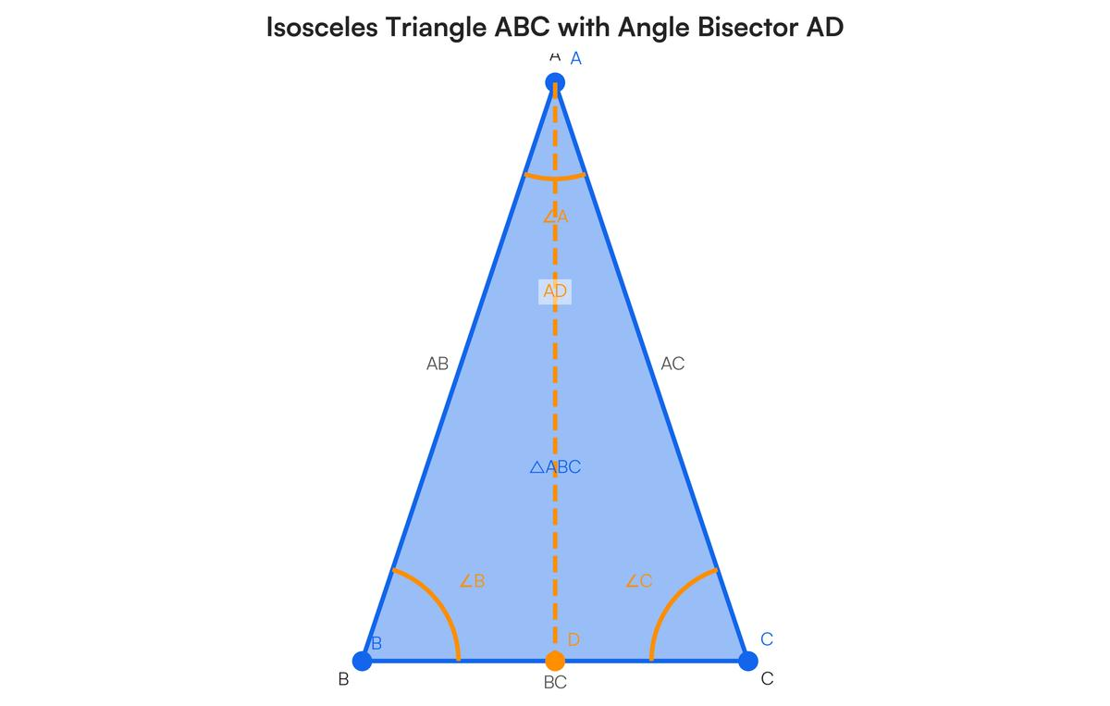
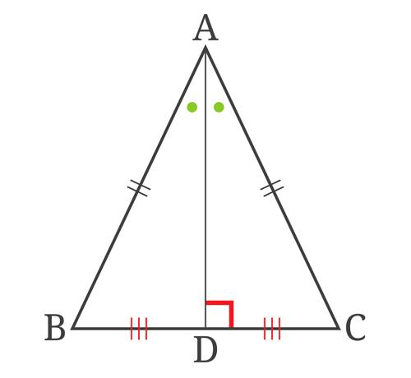
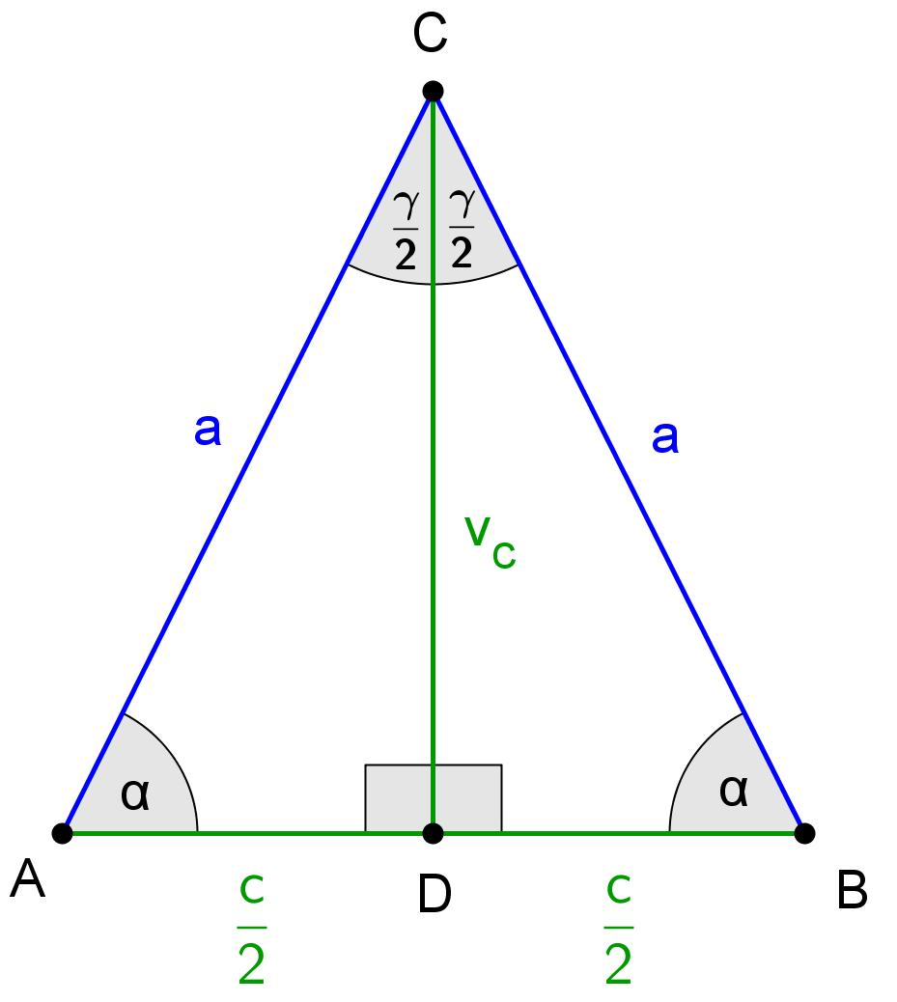
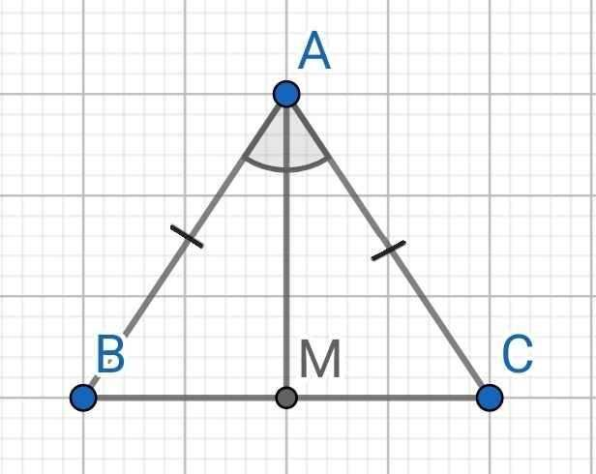

Angle Bisector vs. Median
# Source: AI Source: Provided by: [Data Path: Persons Table -> ID Column: 1, Name_En Column: Motasem Essam] -> From: [ChatGPT] on [7/25/2026]
These are different concepts.
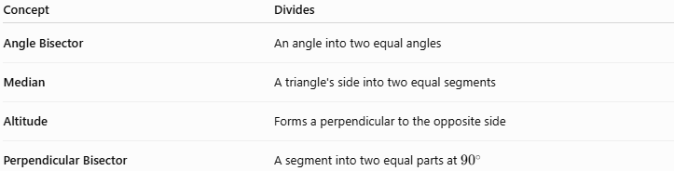
Concept | Divides
Angle Bisector | An angle into two equal angles
Median | A triangle's side into two equal segments
Altitude | Forms a perpendicular to the opposite side
Perpendicular Bisector | A segment into two equal parts at ${90}^{∘}$
An angle bisector is not generally a median or altitude.
However, in certain triangles, such as an isosceles triangle, one line can perform multiple roles.

Angle Bisector vs. Perpendicular Bisector
# Source: AI Source: Provided by: [Data Path: Persons Table -> ID Column: 1, Name_En Column: Motasem Essam] -> From: [ChatGPT] on [7/25/2026]
These are often confused.
Angle Bisector
$$\boxed{∠1=∠2}$$
It creates two equal angles.
Perpendicular Bisector
$$\boxed{AM=MB}$$
and:
$$\boxed{l⊥\overset{‾}{AB}}$$
It creates two equal segments and forms a right angle.

Real-World Applications
# Source: AI Source: Provided by: [Data Path: Persons Table -> ID Column: 1, Name_En Column: Motasem Essam] -> From: [ChatGPT] on [7/25/2026]
Angle bisectors are used in:
- Architecture
- Engineering
- Construction
- Road and intersection design
- Computer graphics
- Robotics
- Navigation
- Technical drawing
- Geometric constructions
For example, when an object must be positioned exactly along the center direction of an angle, an angle bisector provides that direction.

Advantages
# Source: AI Source: Provided by: [Data Path: Persons Table -> ID Column: 1, Name_En Column: Motasem Essam] -> From: [ChatGPT] on [7/25/2026]
- Provides an exact way to divide an angle equally.
- Simplifies many geometric calculations.
- Helps locate the incenter of a triangle.
- Supports geometric constructions.
- Provides proportional relationships through the Angle Bisector Theorem.

Limitations
# Source: AI Source: Provided by: [Data Path: Persons Table -> ID Column: 1, Name_En Column: Motasem Essam] -> From: [ChatGPT] on [7/25/2026]
- An angle bisector does not generally divide the opposite side of a triangle into equal lengths.
- It should not be confused with a perpendicular bisector.
- An angle bisector and a median are generally different lines.
- The Angle Bisector Theorem applies specifically to the appropriate triangle configuration.

Relationship with Related Concepts
# Source: AI Source: Provided by: [Data Path: Persons Table -> ID Column: 1, Name_En Column: Motasem Essam] -> From: [ChatGPT] on [7/25/2026]
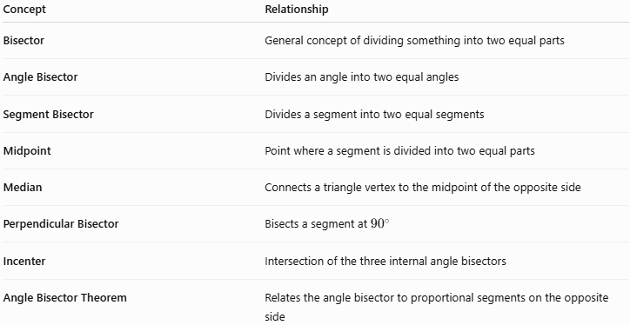
Concept | Relationship
Bisector | General concept of dividing something into two equal parts
Angle Bisector | Divides an angle into two equal angles
Segment Bisector | Divides a segment into two equal segments
Midpoint | Point where a segment is divided into two equal parts
Median | Connects a triangle vertex to the midpoint of the opposite side
Perpendicular Bisector | Bisects a segment at ${90}^{∘}$
Incenter | Intersection of the three internal angle bisectors
Angle Bisector Theorem | Relates the angle bisector to proportional segments on the opposite side

Key Points
# Source: AI Source: Provided by: [Data Path: Persons Table -> ID Column: 1, Name_En Column: Motasem Essam] -> From: [ChatGPT] on [7/25/2026]
- An angle bisector divides an angle into two congruent angles.
- If $BD$bisects $∠ABC$:
$$\boxed{∠ABD=∠DBC}$$
- Each resulting angle is half of the original angle:
$$\boxed{∠ABD=\frac{∠ABC}{2}}$$
- A triangle has three internal angle bisectors.
- The three internal angle bisectors meet at the incenter.
- The Angle Bisector Theorem gives:
$$\boxed{\frac{BD}{DC}=\frac{AB}{AC}}$$
- An angle bisector does not necessarily bisect the opposite side.
- In an isosceles triangle, an angle bisector from the symmetry vertex can also be a median, altitude, and perpendicular bisector.

Conclusion
# Source: AI Source: Provided by: [Data Path: Persons Table -> ID Column: 1, Name_En Column: Motasem Essam] -> From: [ChatGPT] on [7/25/2026]
An angle bisector is a line, ray, or segment that divides an angle into two equal angles. It is a fundamental concept in plane geometry and is especially important in triangle geometry, where angle bisectors lead to the incenter and the Angle Bisector Theorem.

